PD06159_quocpc_Lab1

Activity_main.xml

<?xml version="1.0" encoding="utf-8"?>  
<androidx.constraintlayout.widget.ConstraintLayout xmlns:android="http://schemas.android.com/apk/res/android"  
 xmlns:app="http://schemas.android.com/apk/res-auto"  
 xmlns:tools="http://schemas.android.com/tools"  
 android:layout_width="match_parent"  
 android:layout_height="match_parent"  
 tools:context=".MainActivity">  
  
 <TextView  
 android:layout_width="wrap_content"  
 android:layout_height="wrap_content"  
 android:text="MSV:PD06159"  
 app:layout_constraintBottom_toBottomOf="parent"  
 app:layout_constraintLeft_toLeftOf="parent"  
 app:layout_constraintRight_toRightOf="parent"  
 app:layout_constraintTop_toTopOf="parent" />  
  
 <TextView  
 android:layout_width="wrap_content"  
 android:layout_height="wrap_content"  
 android:text="Name:Phan Cong Quoc"  
 app:layout_constraintBottom_toBottomOf="parent"  
 app:layout_constraintHorizontal_bias="0.514"  
 app:layout_constraintLeft_toLeftOf="parent"  
 app:layout_constraintRight_toRightOf="parent"  
 app:layout_constraintTop_toTopOf="parent"  
 app:layout_constraintVertical_bias="0.539" />  
  
 <TextView  
 android:layout_width="wrap_content"  
 android:layout_height="wrap_content"  
 android:text="Class:MOB1023"  
 app:layout_constraintBottom_toBottomOf="parent"  
 app:layout_constraintHorizontal_bias="0.509"  
 app:layout_constraintLeft_toLeftOf="parent"  
 app:layout_constraintRight_toRightOf="parent"  
 app:layout_constraintTop_toTopOf="parent"  
 app:layout_constraintVertical_bias="0.585" />  
  
</androidx.constraintlayout.widget.ConstraintLayout>

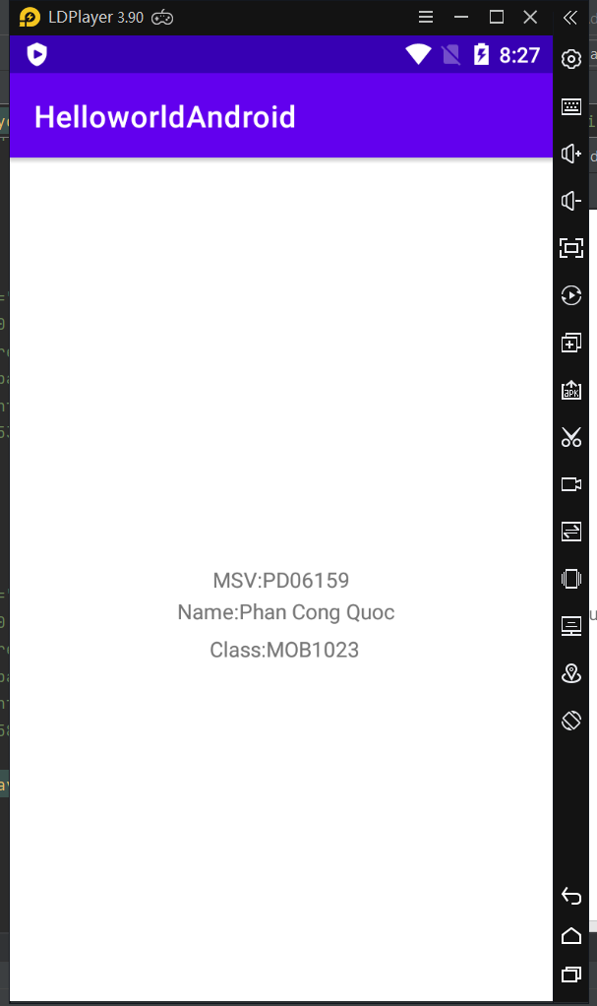S